Legacy Collection – Harvests
- 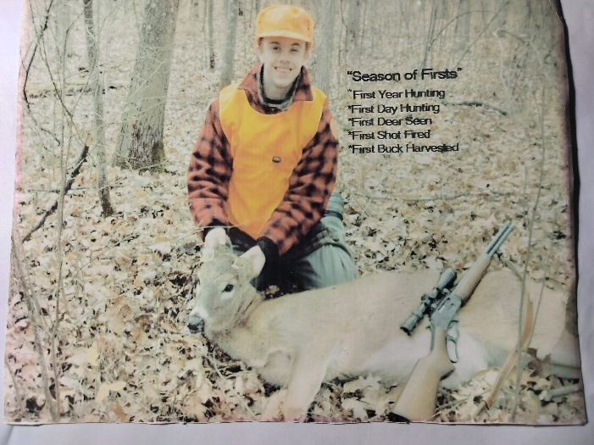
Pine City, MN - Chris’ First and Last Buck
- 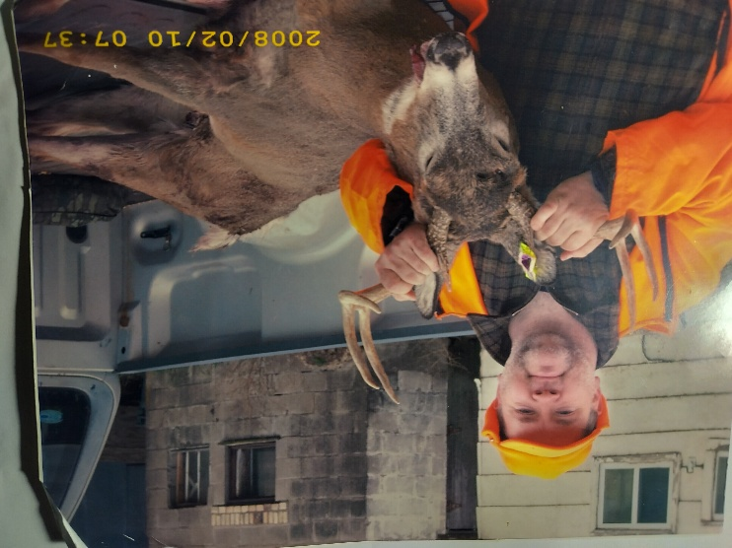
20” 8-pointer shot on Dad’s 30-Year A.D.

- 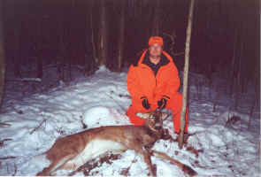
Colby, WI – Lorin’s Fork Horn Buck

Legacy Collection – Harvests
- 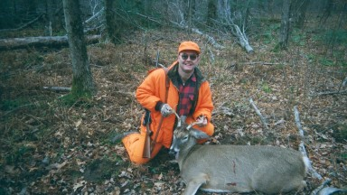
Wausau, WI – Gene’s 8 pt Buck on 25 yr A.D. (1999)

- 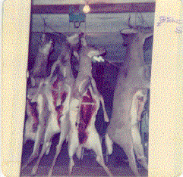
Neillsville, WI – Gene’s 1st Buck in 1974

